EXERCISE 1

BASIC FIGMA DESIGN

AIM:

Use Figma to create a simple mobile app login screen, including basic design and prototyping.

PROCEDURE:

Step 1: Sign Up and Create a New Project

1. Go to figma.com and create an account (if you haven&#39;t already).

2. Once logged in, click &quot;New File&quot; to start a blank project.

3. You&#39;ll see a blank canvas where you can start designing.

Step 2: Create the Frame (Artboard)

1. On the left toolbar, select the &quot;Frame&quot; tool (shortcut: F).

2. Choose a mobile preset (e.g., iPhone 13) from the right-hand panel.

3. A mobile-sized frame will appear on the canvas, which will act as your app screen.

Step 3: Design the Login Screen

Add a Background Color:

1. Select the frame and go to the right-side panel.

2. Under &quot;Fill,&quot; choose a background color (e.g., light blue #E3F2FD).

Insert a Logo:

1. Click the &quot;Rectangle&quot; tool (shortcut: R) and draw a placeholder for a logo.

2. Use the &quot;Text&quot; tool (shortcut: T) to add your app name, e.g., &quot;MyApp&quot;.

3. Adjust font size and color from the right-hand panel.

Add Input Fields:

1. Use the &quot;Rectangle&quot; tool to draw two boxes for username and password fields.

2. Add placeholder text inside (e.g., &quot;Enter your email&quot;).

3. Apply rounded corners under &quot;Corner Radius&quot; in the right panel.

Add a Login Button:

1. Create a button using the &quot;Rectangle&quot; tool and set the color to blue (#1E88E5).

2. Use the &quot;Text&quot; tool to add the text &quot;Login&quot; inside the button.

3. Group the button and text together by selecting them and pressing Ctrl + G

(Windows) or Cmd + G (Mac).

Align Elements:

• Use the alignment tools in the top menu (center everything vertically and

horizontally).

• Adjust spacing between elements using the &quot;Auto Layout&quot; feature (Shift + A).

Step 4: Prototyping the Interaction

1. Click the &quot;Prototype&quot; tab on the right panel.

2. Select the &quot;Login&quot; button and drag the blue dot to a new frame (e.g., a home

screen).

3. Set the interaction to &quot;On Click&quot; → &quot;Navigate to&quot; the next screen.

4. Choose an animation effect (e.g., &quot;Smart Animate&quot;).

Step 5: Preview the Design

1. Click the &quot;Play&quot; button in the top-right corner to preview your app prototype.

2. Try clicking on the login button to see the transition to the next screen.

Step 6: Share Your Design

1. Click the &quot;Share&quot; button in the top-right corner.

2. You can invite team members via email or generate a shareable link.

3. Adjust permissions (View, Edit, or Comment only).

Step 7: Export Assets

1. Select the elements you want to export (e.g., the logo or button).

2. In the right-hand panel, click &quot;Export&quot; and choose a format (PNG, JPG, SVG).

3. Click &quot;Export&quot; to download assets for developers.

Example 2:

Example: Design a Mobile Login Screen in Figma

Step 1: Create a New Figma Project

1. Sign Up or Log In: Go to Figma.com and sign in or sign up if you don&#39;t already have

an account.

2. Create a New File: On the Figma homepage, click &quot;New File&quot; to start a new project.

Step 2: Set Up the Artboard (Frame)

1. Select Frame Tool:

On the left sidebar, select the Frame Tool (F).

2. Choose a Mobile Size:

In the right panel, you&#39;ll see different device options. Choose iPhone 13 (or any

mobile size that fits your needs).

3. Canvas:

This creates a blank mobile screen on your canvas (artboard) where you’ll design

your login screen.

Step 3: Add Background Color

1. Select the Frame:

Click on the frame you just created (iPhone 13).

2. Change the Fill Color:

On the right panel, under the Fill section, click the color box and choose a light

background color (for example, #F0F4F8).

Step 4: Add UI Elements

Let’s add the key components of a login screen: Logo, Text Fields, and Button.

1. Add the Logo:

1. Create a Logo Placeholder:

o Select the Rectangle Tool (R) and draw a small square at the top of the

frame.

o You can also use the Text Tool (T) to write &quot;MyApp&quot; or upload a logo image if

you have one.

2. Adjust Logo Size and Position:

o Place the logo at the top center of the frame.

o Adjust the size of the logo to make it look balanced on the screen.

2. Add the Username Field:

1. Draw the Rectangle:

o Select the Rectangle Tool (R) and draw a rounded rectangle below the logo.

2. Change the Color:

o In the right panel, change the fill color to something like #ffffff (white) and

adjust the opacity slightly to make it look like an input field.

3. Add Placeholder Text:

o Select the Text Tool (T) and add text such as “Enter your email” inside the

rectangle.

o Adjust the font size to something readable (e.g., 16px).

3. Add the Password Field:

1. Duplicate the Username Field:

o Select the username field and press Ctrl + D (Windows) or Cmd + D (Mac) to

duplicate it below.

2. Change Placeholder Text:

o Update the text to “Enter your password.”

4. Add the Login Button:

1. Draw the Button:

o Select the Rectangle Tool (R) and draw a rectangle just below the password

field.

2. Style the Button:

o Change the color of the button to #1E88E5 (blue) to make it stand out.

o Use the Text Tool (T) to write “Login” inside the button. Align it centrally.

3. Adjust Corner Radius:

o In the right panel, under Corner Radius, adjust the corners to round them for

a softer button look (e.g., 20px).

Step 5: Align Elements

1. Use Auto Layout:

o Select all elements on the screen (logo, text fields, and button).

o Right-click and choose &quot;Auto Layout&quot;. This will help align and space the

elements evenly.

2. Adjust Spacing:

o Use the Alignment Tools in the top bar to align everything horizontally and

vertically.

Step 6: Add Interaction (Prototyping)

1. Go to Prototype Tab:

At the top-right, click on the Prototype tab.

2. Link Login Button to Next Screen:

o Select the login button and drag the blue circle (right) to a new frame (you

can duplicate the frame to create a &quot;home&quot; screen or success screen).

o Set the interaction to &quot;On Click&quot; → &quot;Navigate to&quot; the next screen.

o Add a transition animation like Smart Animate for smooth movement.

Step 7: Preview Your Design

1. Preview the Prototype:

o Click the Play Button in the top-right corner to preview how the design looks.

o Test the login button to make sure it links to the next screen.

Step 8: Share and Export

1. Share the Design:

o Click &quot;Share&quot; in the top-right corner. You can invite team members to view or

edit the design by email or share a link.

2. Export Assets:

o Select elements like the logo or button, then click &quot;Export&quot; in the bottom-

right corner to download them as PNGs, SVGs, or JPGs.

OUTPUT:

GOOD DESIGN:

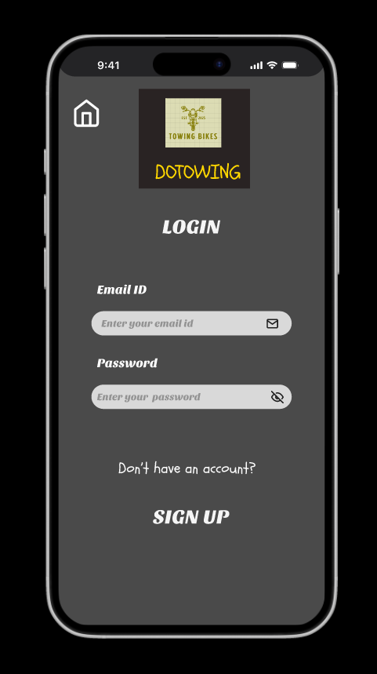

BAD DESIGN:

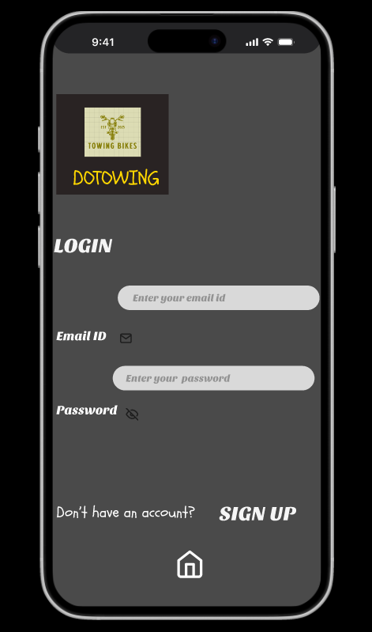

DONE BY:

Sarvesh R (230701295)

CSE – D